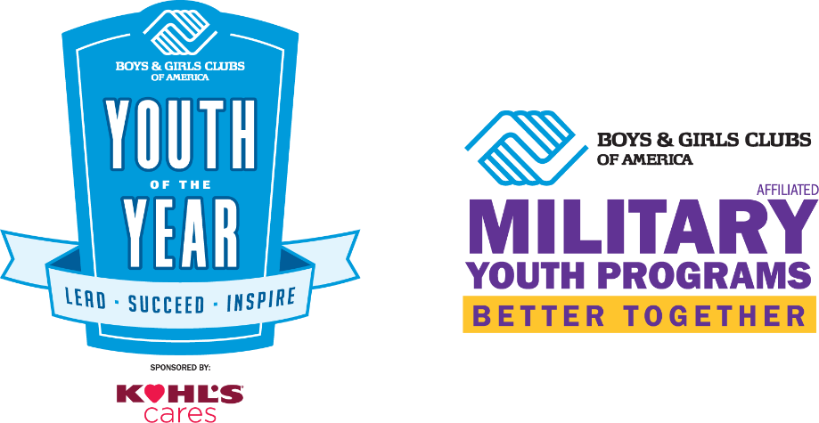
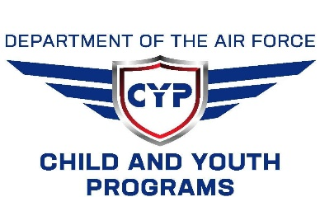

FOR IMMEDIATE RELEASE
Contact:
Pebbles Sambolanay, Vogelweh Teen Center, Carolynne_rose.sambolanay@us.af.mil, DSN 4896155/4896504
EXCEPTIONAL TEENS NAMED ‘LOCAL MILITARY YOUTH OF THE YEAR ’ FOR THEIR TEEN CENTERS in Ramstein and Vogelweh.
Cassandra Ramos and Noah Lutz to Now Vie for State Military Title and Scholarship from Boys & Girls Clubs of America
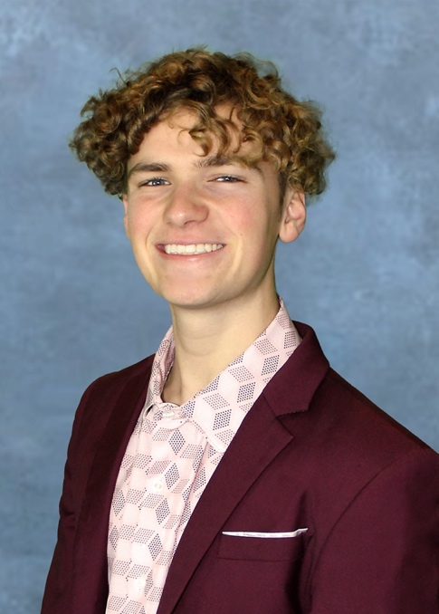
Ramstein and Kaiserslautern, Germany, 20 February 2025– Selected among three outstanding youth, Noah Lutz has been named the Military Youth of the Year by Vogelweh Teen Center. He will be competing alongside Cassandra Ramos, returning candidate of Ramstein Teen Center. The Military Youth of the Year title is a prestigious honor in recognition of leadership, service, academic excellence, dedication to live a healthy lifestyle, and life and workforce readiness. Now in its 78th year, the Youth of the Year program honors our nation’s most awe-inspiring young people on their path to great futures. Noah Lutz will vie for the European Military Youth of the Year title and a $2,500 college scholarship from Kohl’s.
Noah Lutz, is Vice President of both the Keystone Leadership Club and Teen Council at Vogelweh Teen Center, a dedicated leader whose passion for service, mentorship, and the arts has made a lasting impact on his community. He played a key role in earning the prestigious 2023-2024 Roxanne Spillet National Award for Teen Engagement and Workforce Readiness, co-led a coat drive collecting 300 coats for families in Ukraine and the Kaiserslautern Red Cross, and won 1st Place at Nationals in the 2024 National Arts Contest for Performance Art, inspiring his peers to explore creative expression. A passionate mentor, he uses music to foster an inclusive space for teens while consistently maintaining a high academic GPA. Continuing his passion for service to other, he enlisted in the Air Force National Guard, and plans to pursue a college degree in Commercial Music Production, further demonstrating his drive, discipline, and commitment to excellence.
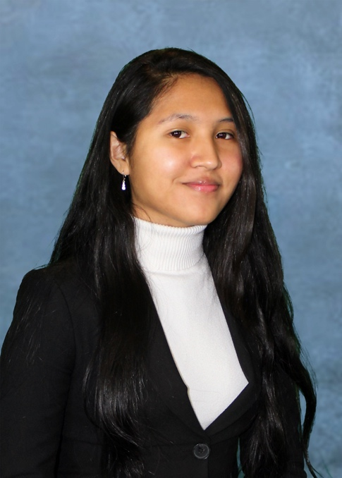
Cassandra Ramos, is President of Ramstein Teen Center’s Keystone Leadership Club for two consecutive years and a valuable member of the National Honor Society, Library Management Team, National Hispanic Recognition Awardee, and an avid volunteer in the community such as the USO. A compassionate, dedicated leader, Cassandra has been an advocate in building up the Ramstein Community through her voice and continuously being and inspiration for positive change in the Youth’s lives through her community service efforts. She continues to share her valuable experiences at last years’ MYOY competition in Naples, BGCA’s National Keystone Conference in Atlanta, and the MYOY Summit in Washington D.C. which helped in recruitment and teen participation at her center. After graduation, she aims to have her Bachelor’s Degree in Psychology at the University of Maryland and Master’s in Counseling Psychology as her long term goal.
Founded in 1947 as Boys & Girls Clubs of America’s premier youth recognition program, Youth of the Year recognize outstanding contributions to a member’s family, school, community, and Boys & Girls Club. Kohl's is the Signature Sponsor of Youth of the Year, sharing a dedication to America's youth. Kohl's is committed to partnering with Boys & Girls Clubs of America to ensure local Clubs and Youth Centers provide staff training and curriculum updates focused on trauma-informed care, building practices kids and teens will need to build great futures.
If one of them get selected at the European (State) Military Youth of the Year, he/she will advance to the regional Military Youth of the Year event, where he/she could receive an additional $20,000 scholarship and move on to the National Military Youth of the Year event to vie for the distinction of National Military Youth of the Year and an additional $20,000 scholarship. The National Military Youth of the Year along with the five regional finalists will advance to the National Youth of the Year event in September 2025 to vie for the title of National Youth of the Year. This final stage of the journey, National Youth of the Year, presents the opportunity for one of the six finalists to be named the National Youth of the Year and receive an additional scholarship of $50,000.
The National MYOY receives $42,500 in scholarships. If that candidate is named the National Youth of the year, he/she will receive a total of $92,500 in scholarships.
For more information about the Youth of the Year program, visit bgca.org/yoy.
About Boys & Girls Clubs of America
For more than 160 years, Boys & Girls Clubs of America (BGCA.org) has provided a safe place for kids and teens to learn and grow. Clubs offer caring adult mentors, fun and friendship, and high-impact youth development programs on a daily basis during critical non-school hours. Boys & Girls Clubs programming promotes academic success, good character and leadership, and healthy lifestyles. Over 5,400 Clubs serve more than 3 million young people through Cl ub membership and community outreach. Clubs are located in cities, towns, public housing and on Native lands throughout the country, and serve military families in BGCA-affiliated Youth Centers on U.S. military installations worldwide. The national headquarters is located in Atlanta. Learn more about Boys & Girls Clubs of America on Facebook and X.

European (State) Military YOY Press Release

