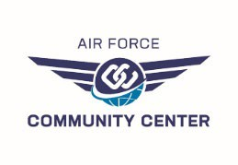Early-Bird Registration

BACK TO SCHOOL FAMILY BINGO

15 August 2025

**Sponsor Name:**

**Email:**

**Phone Number:**

**Guests Attending the Event**

Early-bird price is **$30 per adult,** includes 30 bingo cards (10 sheets, 3 bingo cards per sheet).

|  |  |  |  |  |
| --- | --- | --- | --- | --- |
|  | # Adult Bingo Pk’s ($30) | Extra Single  Cards ($2) | # Kids Bingo Cards ($8) | # Bingo Dauber ($2) |
| Name: |  |  |  |  |
| Name: |  |  |  |  |
| Name: |  |  |  |  |
| Name: |  |  |  |  |
| Name: |  |  |  |  |
| Name: |  |  |  |  |
| Total: |  |  |  |  |

**\*\*\*All sales are FINAL\*\*\*\***

Must be a DoD cardholder to play and win. Send registration forms to: [ramcomcen@gmail.com.](mailto:ramcomcen@gmail.com) Forms can also be submitted in person at the Ramstein Community Center until 5pm on 14th August. Registration is not complete without payment.

Call or visit us in building 412 to complete payment.

=====================================FOR RCC STAFF ONLY=======================================

Sales Total: RecTrac Receipt Number: Staff Initials: